Name: <Dessa S.> Period: < 3> Date:<4/15>

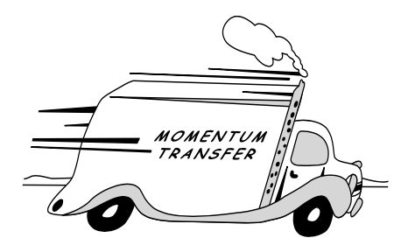

**“Understanding Car Crashes**

**It’s Basic Physics”**

Video Concept Organizer

| Time  2:15  2:50  3:20  4:00  4:35  Time  5:20  5:35  6:05  6:18  6:45  7:10  8:20  9:04  9:42  12:55  13:50  14:30 | Running Time:  22 Minutes  Directions:  To help you remember the key physics concepts discussed while viewing the video, fill in the blanks or *“highlight”* the correct answer.  Video Scenes & Key Concepts  Test Track Laws  Why did the dummy get left behind? It is called Inertia. The property of matter that causes it to resist any change in its state of motion.  Isaac Newton’s “*highlight one”* 1st 2nd 3rd Law of Motion states : A Body at rest remains at Will stay at rest unless acted upon by an external force, and a Body in motion continues to move at a constant speed in a straight line unless it acted on by an external force.  Crashing Dummies  Now watch what happens when the care crashes into a barrier. The front end of the car is crushing and absorbing energy which slows down the rest of the car.  In this case, it is the steering wheel and windshield that applies the external force that overcomes the dummy’s inertia.    Crash-Barrier Chalkboard  Newton explained the relationship between crash forces and inertial in his “*highlight one”* 1st 2nd 3rd Law of Motion.  (Fill in the Blanks to explain what each letter in the formula represents)  F = Force → F= ma m = Mass a = Acceleration  F = $\frac{mΔv}{t}$ $Δv$ = change of velocity t = time  Ft = force times time → $Ft = mΔv$ $mΔv$ = mass times the change in velocity  Surferts, Cheetahs, and Elephants… oh my!  Momentum is inertia in motion. It is the product of an object’s mass and its speed.  Which has more momentum? An 80,000 pound big rig traveling at 2 mph or a 4000 pound SUV traveling at 40 mph? “*highlight one”* Big Rig SUV Same  Soccer Kicks, Slap Shots and Egg Toss  What is it that changes an object’s momentum? An impulse It is the product of the force and the time for which it acts.  If the eggs are of equal mass and are thrown at the same velocity they will have the same momentum. The wall and the sheet both appy equal impulses.  The wall applies a large force over a short time, while the sheet applies a small force over a longer time.  With panic braking the driver stops in less time or distance and experience more Force  Crashing and Smashing  The second animated vehicles front end is less stiff so it crushes two feet instead of one, causing the deceleration to get cut in half.  Extending the time of impact is the basis for many of the ideas about keeping people safe in crashes. List three applications in vehicle or highway safety.   1. Airbags 2. breakaway utility poles 3.<crash cushions>   Conserving Momentum and Energy- its the Law!  In a collision of two cars of unequal mass, the occupants of the lighter care would experience much higher accelerations, hence much higher forces than the occupants of the heavier car.  Motion related energy is called kinetic energy. Energy due to an objects position or condition is called potential energy.  At what point in the pendulum’s swing is it’s potential energy equal to its kinetic energy? Half way When is it’s kinetic energy at its maximum? At the end/ bottom of the swing  *Highlight* the correct formula for kinetic energy (KE) $KE =\frac{1}{2} m2v$ $KE = \frac{1}{2}2m{{v{{{}^{2}}^{}}^{}}^{}}^{}$ $KE = \frac{1}{2}mv{}^{2}$ $KE = \frac{1}{2} mv2$ |
| --- | --- |